**Name: k reddy purandhar**

**Reg.no: 192011484**

**CODE: CSA0734**

**EXPERIMENT: 17**

**AIM:** To implement of server –client using TCP socket pocket programming.

**ALGORITHM:**

1. Create a socket: Create a TCP socket to listen for incoming client connections.
2. Bind the socket to an IP address and port number: Specify the IP address and port number for the server to listen on.
3. Listen for incoming connections: Use the listen() function to start listening for incoming connections from clients.
4. Accept incoming connections: Use the accept() function to accept incoming client connections.
5. Receive data from the client: Use the recv() function to receive data from the client.
6. Process the data: Process the received data as required by the application.
7. Send response to the client: Use the send() function to send a response back to the client.
8. Close the connection: Use the close() function to close the connection with the client.
9. Repeat steps 4 to 8 as required to handle multiple clients.

**PROCEDURE:**

Client Side:

1. Create a socket: Create a TCP socket to connect to the server.
2. Connect to the server: Use the connect() function to connect to the server using the server's IP address and port number.
3. Send data to the server: Use the send() function to send data to the server.
4. Receive response from the server: Use the recv() function to receive a response from the server.
5. Process the response: Process the received response as required by the application.
6. Close the connection: Use the close() function to close the connection with the server.
7. Exit the program: Exit the program as required.

**OUTPUT:**

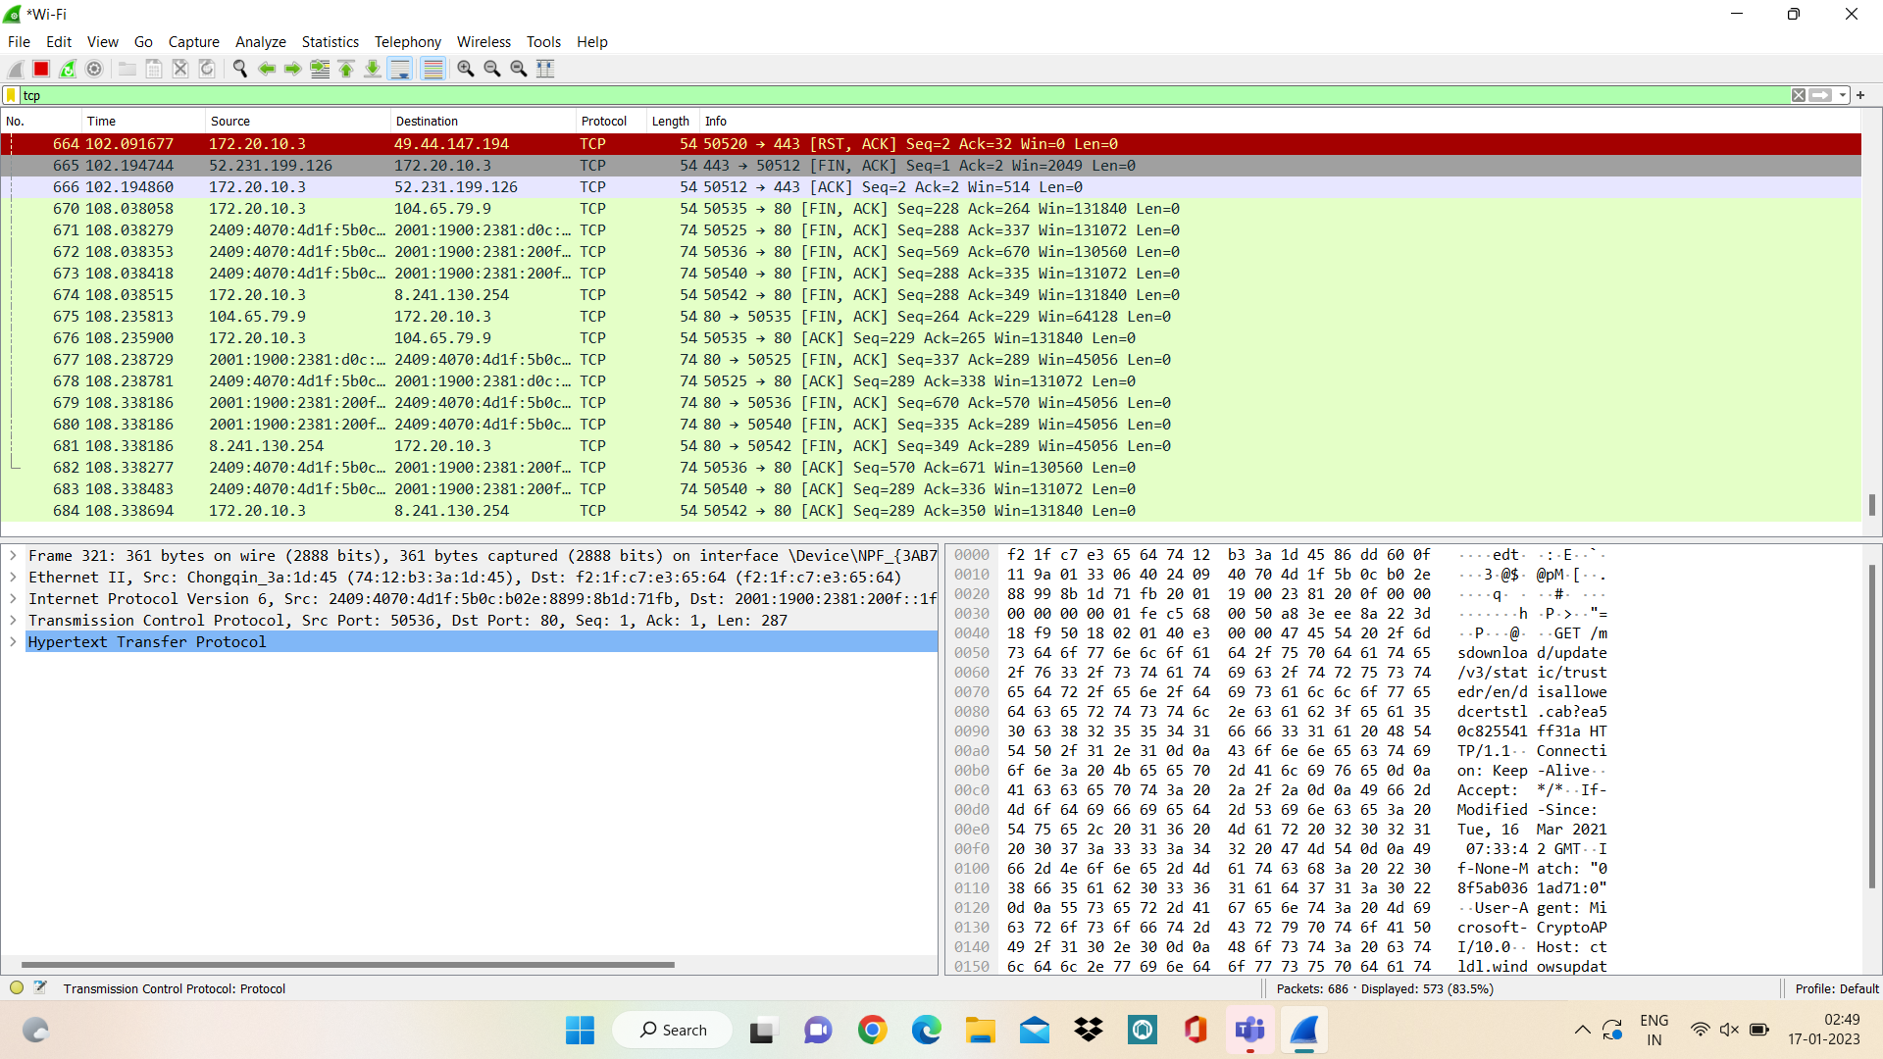

**RESULT:**

Therefore implementation of server has been successfully done using TCP socket programming.